Lab 0: Installing an Operating System

Part 1: Installing Linux (15 pts)

Create a virtual machine in virtualbox and install Ubuntu Gnome.

Within the Linux environment, change your desktop background.

Post a screenshot of your modified desktop in this document.

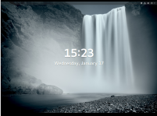

Part 2: Look up the following linux commands on the internet and provide a description of what they do in your own words:

apt-get- is for handling certain types of packages

sudo- allows one to use another users security privileges of another person on Unix program

cat- allows to create and transfer to another exiting folder

ls – a simple command that can be given to a program

Part 3: Look at the list of quotes from the principal developer of Linux, Linus Torvalds, at https://en.wikiquote.org/wiki/Linus_Torvalds . Find 3 that you think are interesting a post them below.

If you need more than 3 levels of indentation, you're screwed anyway, and should fix your program.

Only wimps use tape backup: real men just upload their important stuff on ftp, and let the rest of the world mirror it

…the Linux philosophy is "laugh in the face of danger". Oops. Wrong one. "Do it yourself". That's it.

If you still don't like it, that's OK: that's why I'm boss. I simply know better than you do.